How to control a HD44780-based Character-LCD
(Industry-Standard-Character-LCD)
General info and code-examples

1.1. Pin assignment
The pin assignment shown in Table 1.1. is the industry standard for character LCD-modules with a maximum of 80 characters.
The pin assignment shown in Table 1.2. is the industry standard for character LCD-modules with more than 80 characters.
To be sure always check the manufacturers datasheet!
To locate pin 1 on a module check the manufacturers datasheet!
Table1.1., Pin assignment for <= 80 character displays
Pin number | Symbol | Level | I/O | Function
1 | Vss | - | - | Power supply (GND)
2 | Vcc | - | - | Power supply (+5V)
3 | Vee | - | - | Contrast adjust
4 | RS | 0/1 | I | 0 = Instruction input  1 = Data input
5 | R/W | 0/1 | I | 0 = Write to LCD module  1 = Read from LCD module
6 | E | 1, 1-->0 | I | Enable signal
7 | DB0 | 0/1 | I/O | Data bus line 0 (LSB)
8 | DB1 | 0/1 | I/O | Data bus line 1
9 | DB2 | 0/1 | I/O | Data bus line 2
10 | DB3 | 0/1 | I/O | Data bus line 3
11 | DB4 | 0/1 | I/O | Data bus line 4
12 | DB5 | 0/1 | I/O | Data bus line 5
13 | DB6 | 0/1 | I/O | Data bus line 6
14 | DB7 | 0/1 | I/O | Data bus line 7 (MSB)

Table 1.2., Pin assignment for > 80 character displays
Pin number | Symbol | Level | I/O | Function
1 | DB7 | 0/1 | I/O | Data bus line 7 (MSB)
2 | DB6 | 0/1 | I/O | Data bus line 6
3 | DB5 | 0/1 | I/O | Data bus line 5
4 | DB4 | 0/1 | I/O | Data bus line 4
5 | DB3 | 0/1 | I/O | Data bus line 3
6 | DB2 | 0/1 | I/O | Data bus line 2
7 | DB1 | 0/1 | I/O | Data bus line 1
8 | DB0 | 0/1 | I/O | Data bus line 0 (LSB)
9 | E1 | 1, 1->0 | I | Enable signal row 0 & 1
10 | R/W | 0/1 | I | 0 = Write to LCD module  1 = Read from LCD module
11 | RS | 0/1 | I | 0 = Instruction input  1 = Data input
12 | Vee | - | - | Contrast adjust
13 | Vss | - | - | Power supply (GND)
14 | Vcc | - | - | Power supply (+5V)
15 | E2 | 1, 1->0 | I | Enable signal row 2 & 3
16 | n.c.

1.2. Instruction set
Table 1.3. HD44780 instruction set
Instruction | Code |  |  |  |  |  |  |  |  |  | Description | Execution time**
Instruction | RS | R/W | DB7 | DB6 | DB5 | DB4 | DB3 | DB2 | DB1 | DB0 | Description | Execution time**
Clear display | 0 | 0 | 0 | 0 | 0 | 0 | 0 | 0 | 0 | 1 | Clears display and returns cursor to the home position (address 0). | 1.64mS
Cursor home | 0 | 0 | 0 | 0 | 0 | 0 | 0 | 0 | 1 | * | Returns cursor to home position (address 0). Also returns display being shifted to the original position. DDRAM contents remains unchanged. | 1.64mS
Entry mode set | 0 | 0 | 0 | 0 | 0 | 0 | 0 | 1 | I/D | S | Sets cursor move direction (I/D), specifies to shift the display (S). These operations are performed during data read/write. | 40uS
Display On/Off control | 0 | 0 | 0 | 0 | 0 | 0 | 1 | D | C | B | Sets On/Off of all display (D), cursor On/Off (C) and blink of cursor position character (B). | 40uS
Cursor/display shift | 0 | 0 | 0 | 0 | 0 | 1 | S/C | R/L | * | * | Sets cursor-move or display-shift (S/C), shift direction (R/L). DDRAM contents remains unchanged. | 40uS
Function set | 0 | 0 | 0 | 0 | 1 | DL | N | F | * | * | Sets interface data length (DL), number of display line (N) and character font(F). | 40uS
Set CGRAM address | 0 | 0 | 0 | 1 | CGRAM address |  |  |  |  |  | Sets the CGRAM address. CGRAM data is sent and received after this setting. | 40uS
Set DDRAM address | 0 | 0 | 1 | DDRAM address |  |  |  |  |  |  | Sets the DDRAM address. DDRAM data is sent and received after this setting. | 40uS
Read busy-flag and address counter | 0 | 1 | BF | CGRAM / DDRAM address |  |  |  |  |  |  | Reads Busy-flag (BF) indicating internal operation is being performed and reads CGRAM or DDRAM address counter contents (depending on previous instruction). | 0uS
Write to CGRAM or DDRAM | 1 | 0 | write data |  |  |  |  |  |  |  | Writes data to CGRAM or DDRAM. | 40uS
Read from CGRAM or DDRAM | 1 | 1 | read data |  |  |  |  |  |  |  | Reads data from CGRAM or DDRAM. | 40uS
Remarks:
- DDRAM = Display Data RAM.
- CGRAM = Character Generator RAM.
- DDRAM address corresponds to cursor position.
- * = Don't care.
- ** = Based on Fosc = 250KHz.
Table1.4. Bit names
Bit name | Settings
I/D | 0 = Decrement cursor position | 1 = Increment cursor position
S | 0 = No display shift | 1 = Display shift
D | 0 = Display off | 1 = Display on
C | 0 = Cursor off | 1 = Cursor on
B | 0 = Cursor blink off | 1 = Cursor blink on
S/C | 0 = Move cursor | 1 = Shift display
R/L | 0 = Shift left | 1 = Shift right
DL | 0 = 4-bit interface | 1 = 8-bit interface
N | 0 = 1/8 or 1/11 Duty (1 line) | 1 = 1/16 Duty (2 lines)
F | 0 = 5x7 dots | 1 = 5x10 dots
BF | 0 = Can accept instruction | 1 = Internal operation in progress
1.3. Visible DDRAM addresses

1.3.1. 1-line displays
Shown after reset (with N=0).
Table1.5. DDRAM address usage for a 1-line LCD
Display size | Visible
Display size | Character positions | DDRAM addresses
1*8 | 00..07 | 00h..07h
1*16 | 00..15 | 00h..0Fh
1*20 | 00..19 | 00h..13h
1*24 | 00..23 | 00h..17h
1*32 | 00..31 | 00h..1Fh
1*40 | 00..39 | 00h..27h

1.3.2. 2-line displays
Shown after reset (with N=1).
Table1.6. DDRAM address usage for a 2-line LCD
Display size | Visible
Display size | Character positions | DDRAM addresses
2*16 | 00..15 | 00h..0Fh + 40h..4Fh
2*20 | 00..19 | 00h..13h + 40h..53h
2*24 | 00..23 | 00h..17h + 40h..57h
2*32 | 00..31 | 00h..1Fh + 40h..5Fh
2*40 | 00..39 | 00h..27h + 40h..67h
1.3.3. 4-line displays
Shown after reset (with N=1).
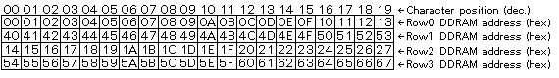
Table 1.7. DDRAM address usage for a 4-line LCD
Display size | Visible
Display size | Character positions | DDRAM addresses
4*16 | 00..15 | 00h..0Fh + 40h..4Fh + 14h..23h + 54h..63h
4*20 | 00..19 | 00h..13h + 40h..53h + 14h..27h + 54h..67h
4*40 | (00..39) on 1st controller and  (00..39) on 2nd controller | (00h..27h + 40h..67h) on 1st controller and  (00h..27h + 40h..67h) on 2nd controller

1.4. Interfacing

1.4.1. 8-bit interface
Example of busy flag testing using an 8-bit interface.
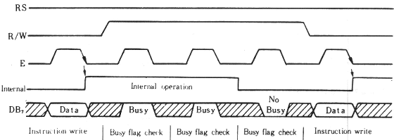
1.4.2. 4-bit interface
Example of busy flag testing using a 4-bit interface.
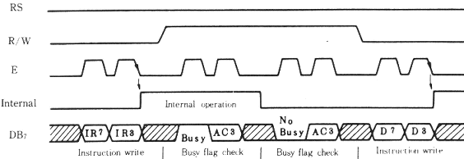

Example of data transfer using a 4-bit interface.
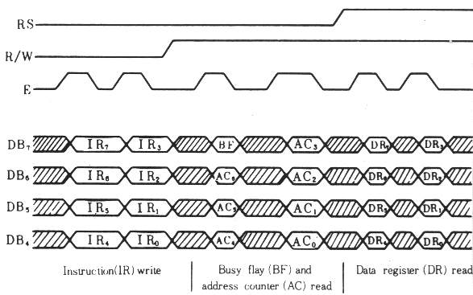

1.5. Characterset for 5x7 dot font 